**DATABASE SYSTEMS:5330**

**PROJECT 1**

**DATABASE FOR MANAGEMENT OF YOUR MUSIC COLLECTION**

**NAME:**

1)SUJAY NATARAJAN(1001086537)

2)VINCENT

3)SAMSON YERRANGUNTLA

4)KINSHUK KASHYUP

5)POONAM SATHE DEEPAK

**TASK1**

**A.**

**1)ALBUM:**

The entity album contains list of albums and their respective id’s. The core of a music collection is the list of albums that I have. It has the following fields album_name, album_id, description and rating so that there is only one rating per album.

**2)ARTIST**:

Artist entity contains the details about the different artists with a description and an id. The artist entity is chosen to provide details about the numerous artists that my collection can contain.

**3)GENRE**:

Genre describes the various genres that an album can be associated with. Genre is a separate entity because multiple genres can be associated to an album and it is easier to keep a list of genres separately. Genre contains genre_id, description, genre category.

**4)ALBUM_ARTIST**:

Album_artist is a separate entity which contains the details about albums with its associated artists. It contains album_id and artist_id to associate different artists to different albums.

**5)ALBUM_GENRE**:

This entity deals with associating different genres to different albums. This is separate because there can be many genres to same album and that is kept track using the album_id and genre_id.

**6)MY_COLLECTION**:

This entity is the core of my music collection and contains various details about albums,release and record date etc. My_Collection describes the collection of albums that I have in my collection which will be able to point out if I have two or more copies of the same album in different conditions or with different disktypes. This entity is chosen because it can help keep track of the albums with a collection id.

**B.ATTRIBUTES**

**1)ALBUM:**

|  |  |
| --- | --- |
| ATTRIBUTE | DATATYPE |
| Album_id | Integer |
| Album_name | Varchar |
| Album_decription | Varchar |
| Rating | Integer |

**2)ARTIST:**

|  |  |
| --- | --- |
| ATTRIBUTE | DATATYPE |
| Artist_id | Integer |
| Artist_name | Integer |

**3)GENRE:**

|  |  |
| --- | --- |
| ATTRIBUTE | DATATYPE |
| Genre_id | Integer |
| Genre | Varchar |
| Genre_description | Varchar |

**4)ALBUM_ARTIST:**

|  |  |
| --- | --- |
| ATTRIBUTE | DATATYPE |
| Album_id | Integer |
| Artist_id | Integer |

**5)ALBUM_GENRE:**

|  |  |
| --- | --- |
| ATTRIBUTE | DATATYPE |
| Album_id | Integer |
| Genre_id | Integer |

**6)MY_COLLECTION:**

|  |  |
| --- | --- |
| ATTRIBUTE | DATATYPE |
| My_id | Integer |
| Album_id | Integer |
| Duration | Integer |
| Number_of_Tracks | Varchar |
| Disktype | Varchar |
| Album_type | Varchar |
| Alcond | Varchar |
| Recorddate | Varchar |
| Releasedate | Varchar |
| Price | Integer |
| Purchase_date | Varchar |

**TASK2**

**B.**

Album table has attribute album_id which is the primary key and is set to not null and uniquely identifies the albums. Artist entity contains primary key artist_id and is also set to not null. The album_artist tables contains the album_id and artist_id as a composite key to signify that each album can have many artists and thus album table and album_artist table is connected in a one to many fashion. The Genre entity contains genre_id as primary key which contains unique ids of different genres. The album_genre entity contains both album_id and genre_id as a composite key to show that each album can have different genres and different albums can be assigned to one genre. Thus this has a many to many relationship. My_collection has my_id and album_id as a composite key which will be helpful in determining that mutiplecopies of the same album can be present in a collection and the composite key uniquely identifies that the same album can be present in the collection in different conditions like CD/Vinyl. Thus my_collection and album are related in a one to many manner. The album_id in my_collection,album_genre,album_artist is a foreign key referencing the album_id in Album table. Similarly Genre_id in album_genre and artist_id in album_artist are foreign keys referencing genre,artist entities repesctively.

**C.**

The three fundamental constraints existing in my schema are :

1)Primary Key

2)foreign Key

3) Set Not Null

And my schema also has set default values if no value is provided .

Album_id, genre_id, artist_id are three different primary keys as explained above for album, genre, artist tables repectively.

Album_id, Genre_id of the Album_genre table are foreign keys referencing to the album_id and genre_id of tables album,genre_repectively. Similarly Album_id, Artist_id of album_artist table are foreign key references to album_id and artist_id of albm, artist tables repecrively.

Album_id of the album table is set to not null and so no null values can be provided for album_id and similarly has been set for artist_id and genre_id.

Recorddate field of my_collection table has additional constraint of setting default value to null if no value is provided.

Task 3

3a)

CREATE TABLE `album` (   `album_id` int(50) NOT NULL,   `album_name` varchar(50) DEFAULT NULL,   `album_desc` varchar(50),   `rating` varchar(45) DEFAULT NULL,   PRIMARY KEY (`album_id`) );

CREATE TABLE `artist` (   `artist_id` int(50) NOT NULL,   `artist_name` varchar(50) DEFAULT NULL,   PRIMARY KEY (`artist_id`) ) ;

CREATE TABLE `genre` (   `genre_id` int(50) NOT NULL,   `genre` varchar(50),   `genre_desc` varchar(50) DEFAULT NULL,   PRIMARY KEY (`genre_id`) );

CREATE TABLE `album_artist` (

`album_id` int(50) NOT NULL DEFAULT '0',

`artist_id` int(50) NOT NULL DEFAULT '0',

PRIMARY KEY (`album_id`,`artist_id`),

CONSTRAINT FOREIGN KEY (`album_id`) REFERENCES `album` (`album_id`) on delete restrict,

CONSTRAINT FOREIGN KEY (`artist_id`) REFERENCES `artist` (`artist_id`) on update no action

) ;

CREATE TABLE `album_genre` (

`album_id` int(50) NOT NULL DEFAULT '0',`genre_id` int(50) NOT NULL DEFAULT '0',

PRIMARY KEY (`album_id`,`genre_id`),

CONSTRAINT `album_genre_ibfk_1` FOREIGN KEY (`album_id`) REFERENCES `album` (`album_id`) on delete restrict ,

CONSTRAINT `album_genre_ibfk_2` FOREIGN KEY (`genre_id`) REFERENCES `genre` (`genre_id`) on delete restrict,

) ;

CREATE TABLE `my_collection` (

`my_id` int(50) NOT NULL DEFAULT '0',

`album_id` int(50) NOT NULL DEFAULT '0',

`duration` int(50),

`number_of_tracks` varchar(50),

`disktype` varchar(50),

`album_type` varchar(50),

`alcond` varchar(50),

`recorddate` varchar(50),

`releasedate` varchar(50) DEFAULT NULL,

`price` varchar(50) DEFAULT NULL,

`purchase_date` varchar(50) DEFAULT NULL,

`numberofcopies` int(50) DEFAULT NULL,

PRIMARY KEY (`my_id`,`album_id`),

CONSTRAINT ` FOREIGN KEY (`album_id`) REFERENCES `album`’(`album_id`) on update no action

) ;

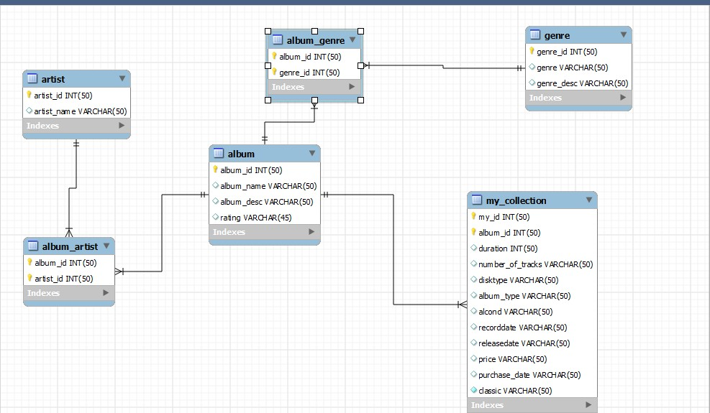

**ON UPDATE AND ON DELETE:**

1)ALBUM_ARTIST:

CONSTRAINT FOREIGN KEY (`album_id`) REFERENCES `album` (`album_id`) on update cascade on delete restrict,

CONSTRAINT FOREIGN KEY (`artist_id`) REFERENCES `artist` (`artist_id`) on update cascade on delete restrict

On update of album_id and artist_id has been set to cascade so that if there is any changes in album or artist table it will be cascaded and on delete operation is restricted so that no values from artist or album is deleted.

2)ALBUM_GENRE:

CONSTRAINT `album_genre_ibfk_1` FOREIGN KEY (`album_id`) REFERENCES `album` (`album_id`) on delete restrict on update cascade ,

CONSTRAINT `album_genre_ibfk_2` FOREIGN KEY (`genre_id`) REFERENCES `genre` (`genre_id`) on delete restrict on update cascade,

On delete operation on Album_id and genre_id is restricted so that no deletion occurs in album or genre table and if there is any update it is cascaded.

3)MY_COLLECTION:

CONSTRAINT ` FOREIGN KEY (`album_id`) REFERENCES `album`’(`album_id`) on update no action

On update of my collection album id then no action is taken on album_id in album table so that no values are modified.

3b)

**Album:**

INSERT INTO `album` (`album_id`,`album_name`,`album_desc`,`rating`) VALUES (1,'Master of puppets','favorite','5');

INSERT INTO `album` (`album_id`,`album_name`,`album_desc`,`rating`) VALUES (2,'Load','another brick in the wall','5');

INSERT INTO `album` (`album_id`,`album_name`,`album_desc`,`rating`) VALUES (3,'Mall','parkit','3');

INSERT INTO `album` (`album_id`,`album_name`,`album_desc`,`rating`) VALUES (4,'Slumdog','BGM','2');

INSERT INTO `album` (`album_id`,`album_name`,`album_desc`,`rating`) VALUES (5,'back in black','highway to hell','2');

INSERT INTO `album` (`album_id`,`album_name`,`album_desc`,`rating`) VALUES (6,'Powerslave','favorite','1');

INSERT INTO `album` (`album_id`,`album_name`,`album_desc`,`rating`) VALUES (7,'Roja','ARR','4');

INSERT INTO `album` (`album_id`,`album_name`,`album_desc`,`rating`) VALUES (8,'Death Magnetic','Rock','5');

INSERT INTO `album` (`album_id`,`album_name`,`album_desc`,`rating`) VALUES (9,'Ride the lightening','awesome','3');

INSERT INTO `album` (`album_id`,`album_name`,`album_desc`,`rating`) VALUES (10,'another brick in the wall','no education','4');

**Artist:**

INSERT INTO `artist` (`artist_id`,`artist_name`) VALUES (1,'Metallica');

INSERT INTO `artist` (`artist_id`,`artist_name`) VALUES (2,'pink floyd');

INSERT INTO `artist` (`artist_id`,`artist_name`) VALUES (3,'linkin park');

INSERT INTO `artist` (`artist_id`,`artist_name`) VALUES (4,'Slumdog');

INSERT INTO `artist` (`artist_id`,`artist_name`) VALUES (5,'acdc');

INSERT INTO `artist` (`artist_id`,`artist_name`) VALUES (6,NULL);

INSERT INTO `artist` (`artist_id`,`artist_name`) VALUES (7,NULL);

INSERT INTO `artist` (`artist_id`,`artist_name`) VALUES (8,'ARR');

INSERT INTO `artist` (`artist_id`,`artist_name`) VALUES (9,NULL);

INSERT INTO `artist` (`artist_id`,`artist_name`) VALUES (10,'Iron Maiden');

**Genre:**

INSERT INTO `genre` (`genre_id`,`genre`,`genre_desc`) VALUES (1,'hard rock','headbang');

INSERT INTO `genre` (`genre_id`,`genre`,`genre_desc`) VALUES (2,'pop','have fun');

INSERT INTO `genre` (`genre_id`,`genre`,`genre_desc`) VALUES (3,'metal','listen');

INSERT INTO `genre` (`genre_id`,`genre`,`genre_desc`) VALUES (4,'classical','rythym');

INSERT INTO `genre` (`genre_id`,`genre`,`genre_desc`) VALUES (5,'country','normal');

INSERT INTO `genre` (`genre_id`,`genre`,`genre_desc`) VALUES (6,'techno','dj');

**Album_genre:**

INSERT INTO `album_genre` (`album_id`,`genre_id`) VALUES (1,1);

INSERT INTO `album_genre` (`album_id`,`genre_id`) VALUES (6,1);

INSERT INTO `album_genre` (`album_id`,`genre_id`) VALUES (3,2);

INSERT INTO `album_genre` (`album_id`,`genre_id`) VALUES (8,2);

INSERT INTO `album_genre` (`album_id`,`genre_id`) VALUES (2,3);

INSERT INTO `album_genre` (`album_id`,`genre_id`) VALUES (5,3);

INSERT INTO `album_genre` (`album_id`,`genre_id`) VALUES (10,3);

INSERT INTO `album_genre` (`album_id`,`genre_id`) VALUES (4,4);

INSERT INTO `album_genre` (`album_id`,`genre_id`) VALUES (7,4);

INSERT INTO `album_genre` (`album_id`,`genre_id`) VALUES (4,5);

INSERT INTO `album_genre` (`album_id`,`genre_id`) VALUES (7,5);

INSERT INTO `album_genre` (`album_id`,`genre_id`) VALUES (9,5);

INSERT INTO `album_genre` (`album_id`,`genre_id`) VALUES (5,6);

**Album_artist:**

INSERT INTO `album_artist` (`album_id`,`artist_id`) VALUES (1,1);

INSERT INTO `album_artist` (`album_id`,`artist_id`) VALUES (8,1);

INSERT INTO `album_artist` (`album_id`,`artist_id`) VALUES (1,2);

INSERT INTO `album_artist` (`album_id`,`artist_id`) VALUES (2,2);

INSERT INTO `album_artist` (`album_id`,`artist_id`) VALUES (9,2);

INSERT INTO `album_artist` (`album_id`,`artist_id`) VALUES (10,2);

INSERT INTO `album_artist` (`album_id`,`artist_id`) VALUES (3,3);

INSERT INTO `album_artist` (`album_id`,`artist_id`) VALUES (2,4);

INSERT INTO `album_artist` (`album_id`,`artist_id`) VALUES (7,4);

INSERT INTO `album_artist` (`album_id`,`artist_id`) VALUES (3,6);

INSERT INTO `album_artist` (`album_id`,`artist_id`) VALUES (5,7);

INSERT INTO `album_artist` (`album_id`,`artist_id`) VALUES (2,8);

INSERT INTO `album_artist` (`album_id`,`artist_id`) VALUES (4,8);

INSERT INTO `album_artist` (`album_id`,`artist_id`) VALUES (5,8);

INSERT INTO `album_artist` (`album_id`,`artist_id`) VALUES (5,9);

INSERT INTO `album_artist` (`album_id`,`artist_id`) VALUES (6,9);

INSERT INTO `album_artist` (`album_id`,`artist_id`) VALUES (5,10);

INSERT INTO `album_artist` (`album_id`,`artist_id`) VALUES (6,10);

**My_Collection:**

INSERT INTO `my_collection` (`my_id`,`album_id`,`duration`,`number_of_tracks`,`disktype`,`album_type`,`alcond`,`recorddate`,`releasedate`,`price`,`purchase_date`,`numberofcopies`,`classic`) VALUES (1,1,1510,'5','vinyl','band','good','12-1-1988','2-2-1990','20','1-10-1995',1,'1');

INSERT INTO `my_collection` (`my_id`,`album_id`,`duration`,`number_of_tracks`,`disktype`,`album_type`,`alcond`,`recorddate`,`releasedate`,`price`,`purchase_date`,`numberofcopies`,`classic`) VALUES (2,1,460,'2','Vinyl','Band','Mint','1-11-985','2-3-1988','25','10-12-1994',2,'1');

INSERT INTO `my_collection` (`my_id`,`album_id`,`duration`,`number_of_tracks`,`disktype`,`album_type`,`alcond`,`recorddate`,`releasedate`,`price`,`purchase_date`,`numberofcopies`,`classic`) VALUES (3,10,1410,'10','vinyl','Compilation','Mint','10-5-1988','2-4-2000','23','8-8-1990',1,'1');

INSERT INTO `my_collection` (`my_id`,`album_id`,`duration`,`number_of_tracks`,`disktype`,`album_type`,`alcond`,`recorddate`,`releasedate`,`price`,`purchase_date`,`numberofcopies`,`classic`) VALUES (4,7,2010,'10','Vinyl','Compilation','mint','5-10-1991','10-5-1995','15',NULL,4,'0');

INSERT INTO `my_collection` (`my_id`,`album_id`,`duration`,`number_of_tracks`,`disktype`,`album_type`,`alcond`,`recorddate`,`releasedate`,`price`,`purchase_date`,`numberofcopies`,`classic`) VALUES (5,9,440,'1','CD','single','good','1-12-2012',NULL,'30','9-10-2015',3,'1');

INSERT INTO `my_collection` (`my_id`,`album_id`,`duration`,`number_of_tracks`,`disktype`,`album_type`,`alcond`,`recorddate`,`releasedate`,`price`,`purchase_date`,`numberofcopies`,`classic`) VALUES (6,10,1410,'2','Vinyl','Band','poor','2-3-2015','10-10-2015','0.5',NULL,5,'0');

INSERT INTO `my_collection` (`my_id`,`album_id`,`duration`,`number_of_tracks`,`disktype`,`album_type`,`alcond`,`recorddate`,`releasedate`,`price`,`purchase_date`,`numberofcopies`,`classic`) VALUES (7,6,440,'1','cd','single','Mint','20-12-1976','5-5-1980','12','11-12-1988',4,'0');

INSERT INTO `my_collection` (`my_id`,`album_id`,`duration`,`number_of_tracks`,`disktype`,`album_type`,`alcond`,`recorddate`,`releasedate`,`price`,`purchase_date`,`numberofcopies`,`classic`) VALUES (8,7,440,'1','cd','single','acceptable','1-5-1976','6-6-1980','10','12-11-1984',5,'1');

INSERT INTO `my_collection` (`my_id`,`album_id`,`duration`,`number_of_tracks`,`disktype`,`album_type`,`alcond`,`recorddate`,`releasedate`,`price`,`purchase_date`,`numberofcopies`,`classic`) VALUES (9,5,540,'1','CD','single','mint','5-5-200','10-6-2002','10','8-5-2003',4,'0');

INSERT INTO `my_collection` (`my_id`,`album_id`,`duration`,`number_of_tracks`,`disktype`,`album_type`,`alcond`,`recorddate`,`releasedate`,`price`,`purchase_date`,`numberofcopies`,`classic`) VALUES (10,2,480,'1','CD','Band','acceptable','4-10-2003','11-7-2004','10','7-7-2005',1,'0');

INSERT INTO `my_collection` (`my_id`,`album_id`,`duration`,`number_of_tracks`,`disktype`,`album_type`,`alcond`,`recorddate`,`releasedate`,`price`,`purchase_date`,`numberofcopies`,`classic`) VALUES (11,3,1200,'4','Vinyl','Compilation','Poor','6-10-1949','8-10-1922','17','7-5-2001',2,'0');

INSERT INTO `my_collection` (`my_id`,`album_id`,`duration`,`number_of_tracks`,`disktype`,`album_type`,`alcond`,`recorddate`,`releasedate`,`price`,`purchase_date`,`numberofcopies`,`classic`) VALUES (12,4,1530,'5','CD','Compilation','Good','6-11-1927','8-8-1949','30','5-9-1992',4,'0');

INSERT INTO `my_collection` (`my_id`,`album_id`,`duration`,`number_of_tracks`,`disktype`,`album_type`,`alcond`,`recorddate`,`releasedate`,`price`,`purchase_date`,`numberofcopies`,`classic`) VALUES (13,8,1000,'3','Vinyl','Compilation','poor','10-11-1998','10-9-1998','0.2','7-11-1998',5,'1');

INSERT INTO `my_collection` (`my_id`,`album_id`,`duration`,`number_of_tracks`,`disktype`,`album_type`,`alcond`,`recorddate`,`releasedate`,`price`,`purchase_date`,`numberofcopies`,`classic`) VALUES (14,8,1000,'3','Vinyl','Compilation','mint','11-10-1998','8-10-1998','35','26-11-1998',4,'1');

INSERT INTO `my_collection` (`my_id`,`album_id`,`duration`,`number_of_tracks`,`disktype`,`album_type`,`alcond`,`recorddate`,`releasedate`,`price`,`purchase_date`,`numberofcopies`,`classic`) VALUES (15,2,4030,'2','CD','Single','mint','12-12-2015','10-12-2015','100','9-11-2015',5,'1');

INSERT INTO `my_collection` (`my_id`,`album_id`,`duration`,`number_of_tracks`,`disktype`,`album_type`,`alcond`,`recorddate`,`releasedate`,`price`,`purchase_date`,`numberofcopies`,`classic`) VALUES (16,2,1230,'1','cd','band','mint','1-2-2014','12-4-2014','10','20-12-2015',2,'1');

**TASK4:**

1. select album_name,album.album_id,alcond from album,my_collection where album.album_id=my_collection.album_id;

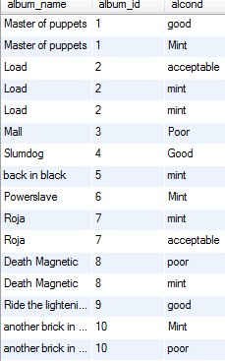

1. select count(album_id) from my_collection;

G:\2.jpg

3) select distinct album.album_id,album_name from my_collection,album where album.album_id=my_collection.album_id;

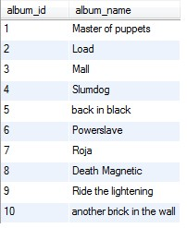

4)select

album_id,count(1) as cnt

from

my_collection

where releasedate is not null

group by album_id;

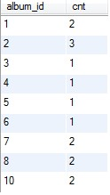

5)select sum(price) from my_collection;

G:\5.jpg

6)select

album.album_id,album_name, count(1) as cnt

from

album,

my_collection

where

album.album_id = my_collection.album_id

group by album_id

having cnt>1;

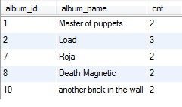

*7)select

album.album_id, artist.artist_id,artist_name,count(1) as cnt

from

album_artist,

album,

artist,

my_collection

where

album.album_id = my_collection.album_id

and artist.artist_id = album_artist.artist_id and album.album_id=album_artist.album_id

group by artist_id;

8)select album.album_id,genre.genre_id,genre,price from genre,album_genre,album,my_collection where album.album_id=my_collection.album_id and album.album_id=album_genre.album_id and genre.genre_id=album_genre.genre_id group by genre having max(price) ;

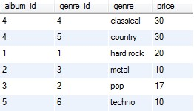

9)select album.album_id,album_name,genre,purchase_date from album,my_collection,album_genre,genre where album.album_id=my_collection.album_id and genre.genre_id=album_genre.genre_id and album.album_id=album_genre.album_id and (genre like'country' or genre like 'classical') having purchase_date>'1980';

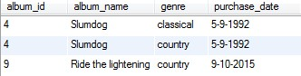

10)select

album.album_id,album_name,count(1) as cnt

from

album,

genre,

album_genre

where

album.album_id = album_genre.album_id

and genre.genre_id = album_genre.genre_id

group by album_id

having cnt>1;

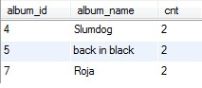

11)select

album.album_id,album_name,count(1) as cnt,album_type

from

album,

genre,

album_genre,

my_collection

where

album.album_id = album_genre.album_id

and genre.genre_id = album_genre.genre_id and album.album_id=my_collection.album_id and album_type not like'compilation'

group by album_id

having cnt>1;

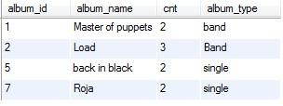

12)select album.album_id,album_name,alcond,rating,disktype from album,my_collection where album.album_id=my_collection.album_id and disktype like 'vinyl'having alcond like'mint' order by rating desc limit 5;

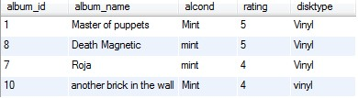

13)select avg(price),disktype from my_collection group by disktype;

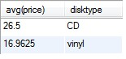

14)

*15)select price,album.album_id,album_name,alcond from album,my_collection where album.album_id=my_collection.album_id and (price=(select min(price) from my_collection)) and alcond like 'mint';

16)select count(album.album_id),album_name,recorddate from album,my_collection where album.album_id=my_collection.album_id and alcond like 'mint' group by recorddate;

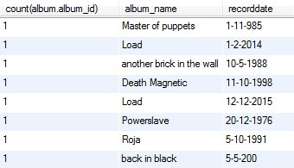

*17)select album.album_id,album_name,artist.artist_id,artist_name from my_collection,album,artist,album_artist where album.album_id=my_collection.album_id and album.album_id=album_artist.album_id and artist.artist_id=album_artist.artist_id and artist_name is null;

18)select album.album_id,artist.artist_id,album_name,artist_name from album,artist,album_artist where album.album_id=album_artist.album_id and artist.artist_id=album_artist.artist_id;

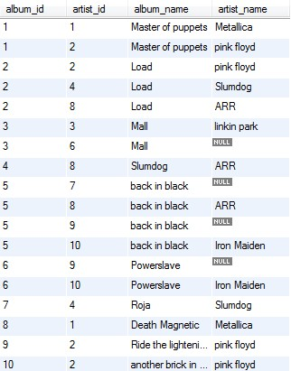

19)select

(got/total)*100 as percentage

from

(select

count(album_id) as total

from

my_collection where album_type = 'single') as t,

(select

count(album.album_id) as got

from

my_collection, album

where

album.album_id = my_collection.album_id

and album_type = 'single'

and rating > 3) as y;

G:\19.jpg

20) select cd_weight+vinyl as sum from

(select

count(disktype)*4 as CD_WEIGHT

from

my_collection

where

disktype='CD') as t,

(select

count(disktype)*9 as vinyl

from

my_collection

where

disktype='vinyl') as y;

G:\20.jpg